**TRAFFICJAM 2015 WINNER RELEASE**

For good and valuable consideration, the receipt and sufficiency of which is hereby acknowledged, I, the undersigned, hereby acknowledge that as a result of my participation in the TrafficJam (the “Hackathon”) conducted by Hackworks, The City of Toronto and Evergreen CityWorks (collectively, the "Sponsors"), I have been selected as the Hackathon winner (the “Winner”), and will receive a prize consisting of my equal share of the $5,000 (collectively, the “Prize”). I acknowledge that the approximate retail value of the total Prize is $5,000 (CDN $5,000).

I hereby acknowledge and confirm that: (a) I have read, understood and complied with the rules governing the Hackathon (the “Hackathon Rules”); (b) the Sponsors have the right to terminate the Hackathon, in whole or in part, or modify, amend or suspend the Hackathon and/or the Hackathon Rules in any way at any time for any reason without prior notice or compensation; and (c) any failure or refusal to abide by the Hackathon Rules shall result in a breach of this agreement and my immediate dismissal from the Hackathon.

I hereby represent and warrant that: (i) the application submitted by me in connection with the Hackathon (the “Application”) is original to me (or, if part of a Team, at least one of the Team members) and all right, title, and interest (including copyright) therein and thereto is owned and/or controlled by me (or my Team) to the full extent necessary for the grant to the Sponsors of a worldwide, gratuitous, irrevocable, and non-exclusive licence to copy, use, modify, reproduce, display, adapt and transmit the Application for use in all media now known or hereafter devised in perpetuity, in connection with the administration, promotion and exploitation of the Hackathon, and for the purposes of marketing, advertising or promoting any of the Sponsors, their products or services; and (ii) the Application meets all other requirements set out in the Hackathon Rules.

I hereby acknowledge and confirm that: (a) the Prize shall be accepted as awarded and cannot be transferred, assigned, substituted], except in the Sponsors’ sole discretion; (b) the Sponsors reserve the right, in their sole discretion, to substitute all or any part of the Prize if the Prize (or any part thereof) cannot be awarded as described; (c) I shall be solely responsible for any expense not specifically described as included in the Prize; and (d) I shall not receive any additional compensation for my appearance, performance and/or participation in the Hackathon, or for any rights granted to the Sponsors herein.

I hereby confirm that the Sponsors do not make, have not made, nor are the Sponsors in any way responsible or liable for, any warranty, representation or guarantee, of any nature whatsoever, expressed or implied, in fact or law, related in any way to the Hackathon and/or the Prize.

I hereby grant to the Sponsors, and their agents, the right to use my name, address, voice, statements about the Hackathon and/or photograph or other likeness, and if I was an In-Person Participant, the right use any such recordings and photographs taken during the Hackathon Period, without further notice or compensation, in any publicity or advertisement carried out by the Sponsors in any manner whatsoever, including print, broadcast or the internet. I hereby assume all risk of injury, illness, disease, death, or any other damage which may arise in connection with the Sponsors’ use of the Application, my participation in the Hackathon and/or my acceptance of the Prize. Without limiting the foregoing,

I hereby RELEASE AND AGREE TO INDEMNIFY AND HOLD HARMLESS THE EMPLOYEES, REPRESENTATIVES AND AGENTS OF THE SPONSORS, AND ANY OF THEIR RESPECTIVE AFFILIATED COMPANIES, REPRESENTATIVES, AGENTS, PRIZE SUPPLIERS, ADVERTISING/PROMOTIONAL AGENCIES AND ANY HACKATHON JUDGES (THE “RELEASED PARTIES”) FROM ANY AND ALL DAMAGES, INJURIES, CLAIMS, CAUSES OF ACTIONS, LIABILITY OR LOSSES OF ANY KIND (INCLUDING ACTUAL LEGAL FEES AND EXPENSES), KNOWN OR UNKNOWN, ABSOLUTE OR CONTINGENT, NOW OR IN THE FUTURE ARISING FROM OR RELATED TO: (A) FAILURE BY ME TO COMPLY WITH ANY OF THE HACKATHON RULES; (B) ANY MISREPRESENTATION MADE BY ME UNDER THE HACKATHON RULES OR OTHERWISE TO ANY OF THE RELEASED PARTIES IN REGARDS TO THE HACKATHON; (C) PARTICIPATION BY ME IN THE HACKATHON WHETHER IN-PERSON OR REMOTELY; (D) RECEIPT, USE OR REDEMPTION OF ANY PRIZE, OR INABILITY TO RECEIVE, USE OR REDEEM ANY PRIZE; (E) ANY CLAIMS BASED ON PUBLICITY RIGHTS, DEFAMATION, INVASION OF PRIVACY, COPYRIGHT INFRINGEMENT, TRADEMARK INFRINGMENT OR ANY OTHER INTELLECTUAL PROPERTY RELATED CAUSE OF ACTION.

I hereby confirm that I have not participated in and will not participate in any unlawful act or any other deceptive or dishonest act with respect to the Hackathon, including without limitation, tampering with the selection process and/or the operation of the Hackathon.

I hereby acknowledge that the Hackathon Rules and this agreement shall apply to and be binding on me and my heirs, executors, administrators, personal representatives, successors and assigns. I acknowledge that the Sponsors, and their respective successors, assigns and licensees, are entitled to assign or license any of the rights granted hereunder to any third party for any purpose whatsoever, and that in the event of any such assignment, this agreement shall remain binding upon me and inure to the benefit of such assignee. I hereby confirm that I am a legal resident of, and I have reached the age of majority in my province or territory of residence. Furthermore, I hereby declare that I am not an employee, representative or agent of any of the Sponsors, their respective affiliated companies, representatives, agents, prize suppliers, advertising/promotional agencies or any Hackathon judges. I acknowledge and confirm that I have read and understood this agreement, and agree to be bound by the terms and conditions contained herein. This agreement shall be governed by and construed in accordance with the laws of the province of Ontario and the laws of Canada as applicable therein, excluding the operation of any rule or principle of conflict of laws.

SIGNED AT____17h00 ET________, ON THIS____8th_____ DAY OF___October____, 2015.

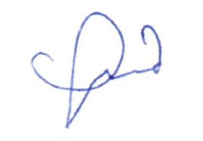

__________________________

Signature

____**Min Amanda Chou**_______

Signature Name (please print)

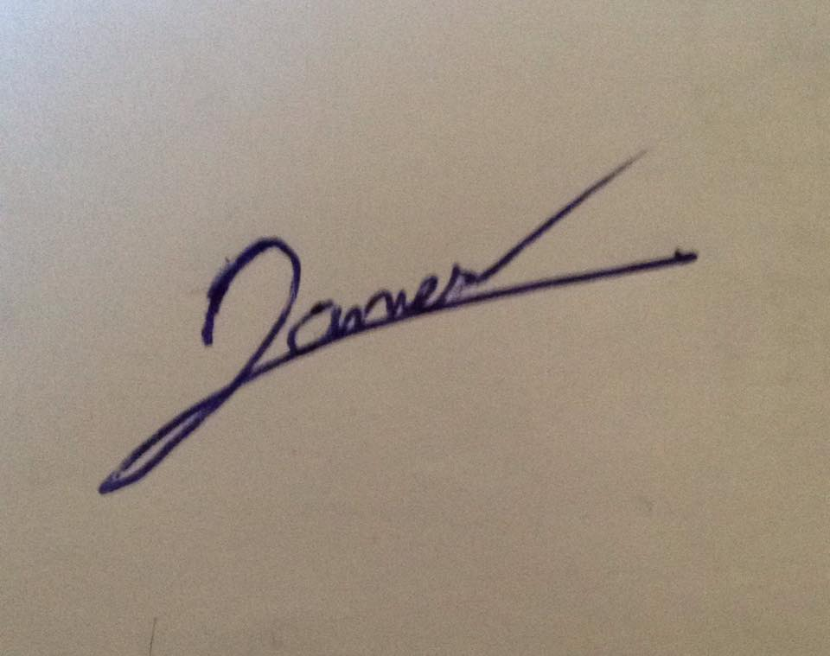

__________________________

Witness’ Signature

___James Lamers____________

Witness’ Name (please print)

Full address, including postal code:

**#426-231 Fort York Boulevard  
Toronto, ON  
M5V 1B2**

Telephone: _____**647-991-9452**______